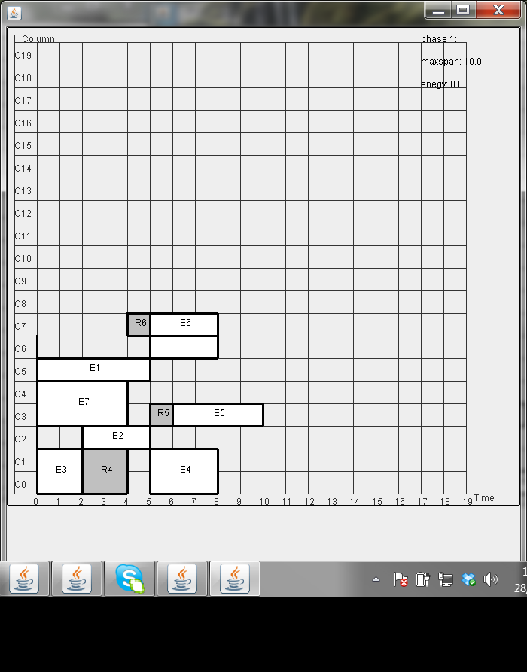

Example 2- ko dung leakage-aware placement

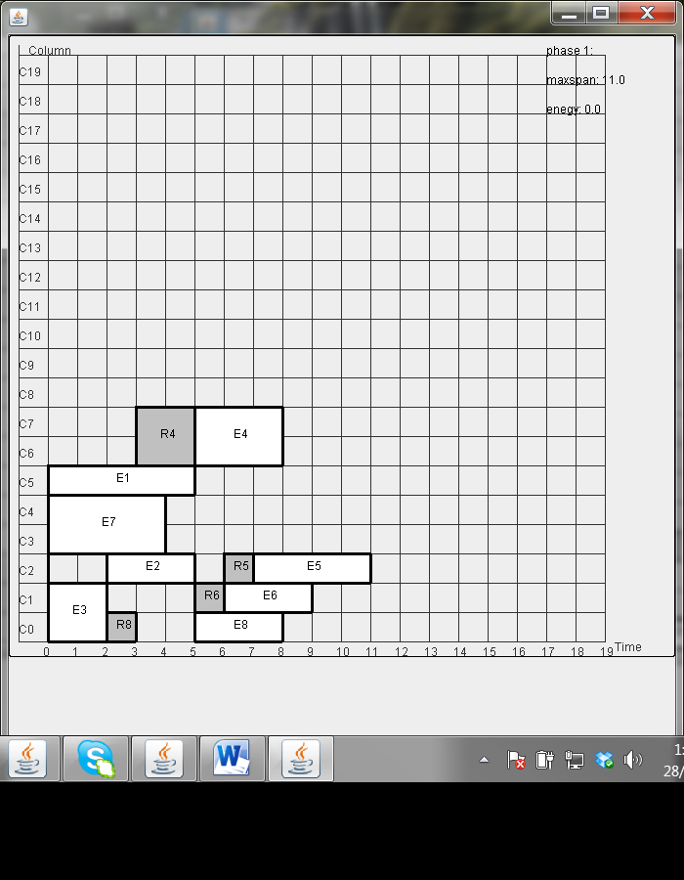

Exmaple 2- with leakage aware placement lk=0, est=1

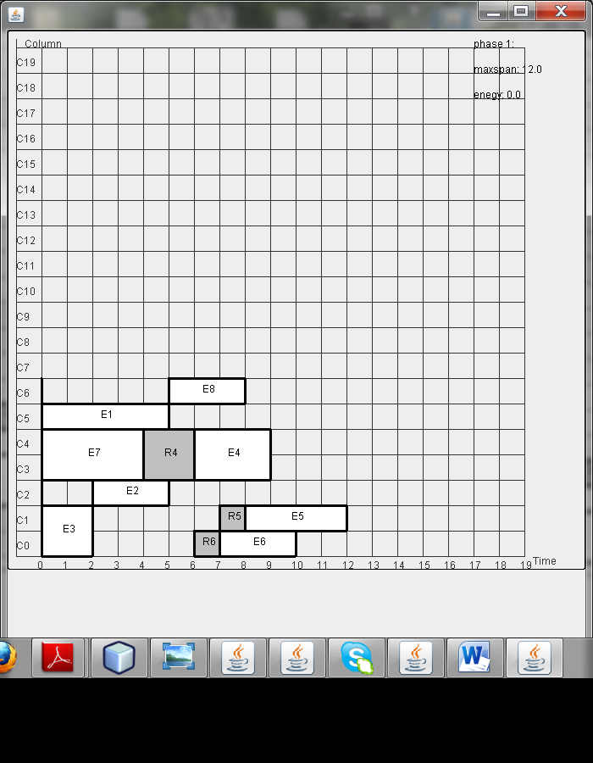

Exmaple 2- with leakage aware placement lk=10, est=1

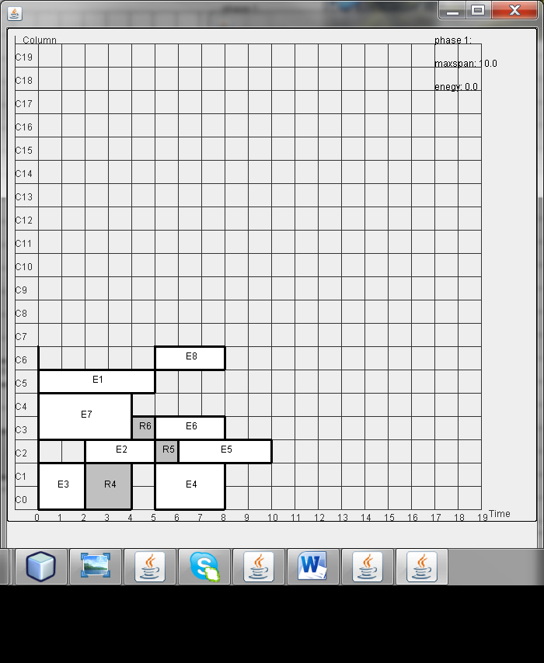

Exmaple 2- with leakage aware placement lk=10, est=10